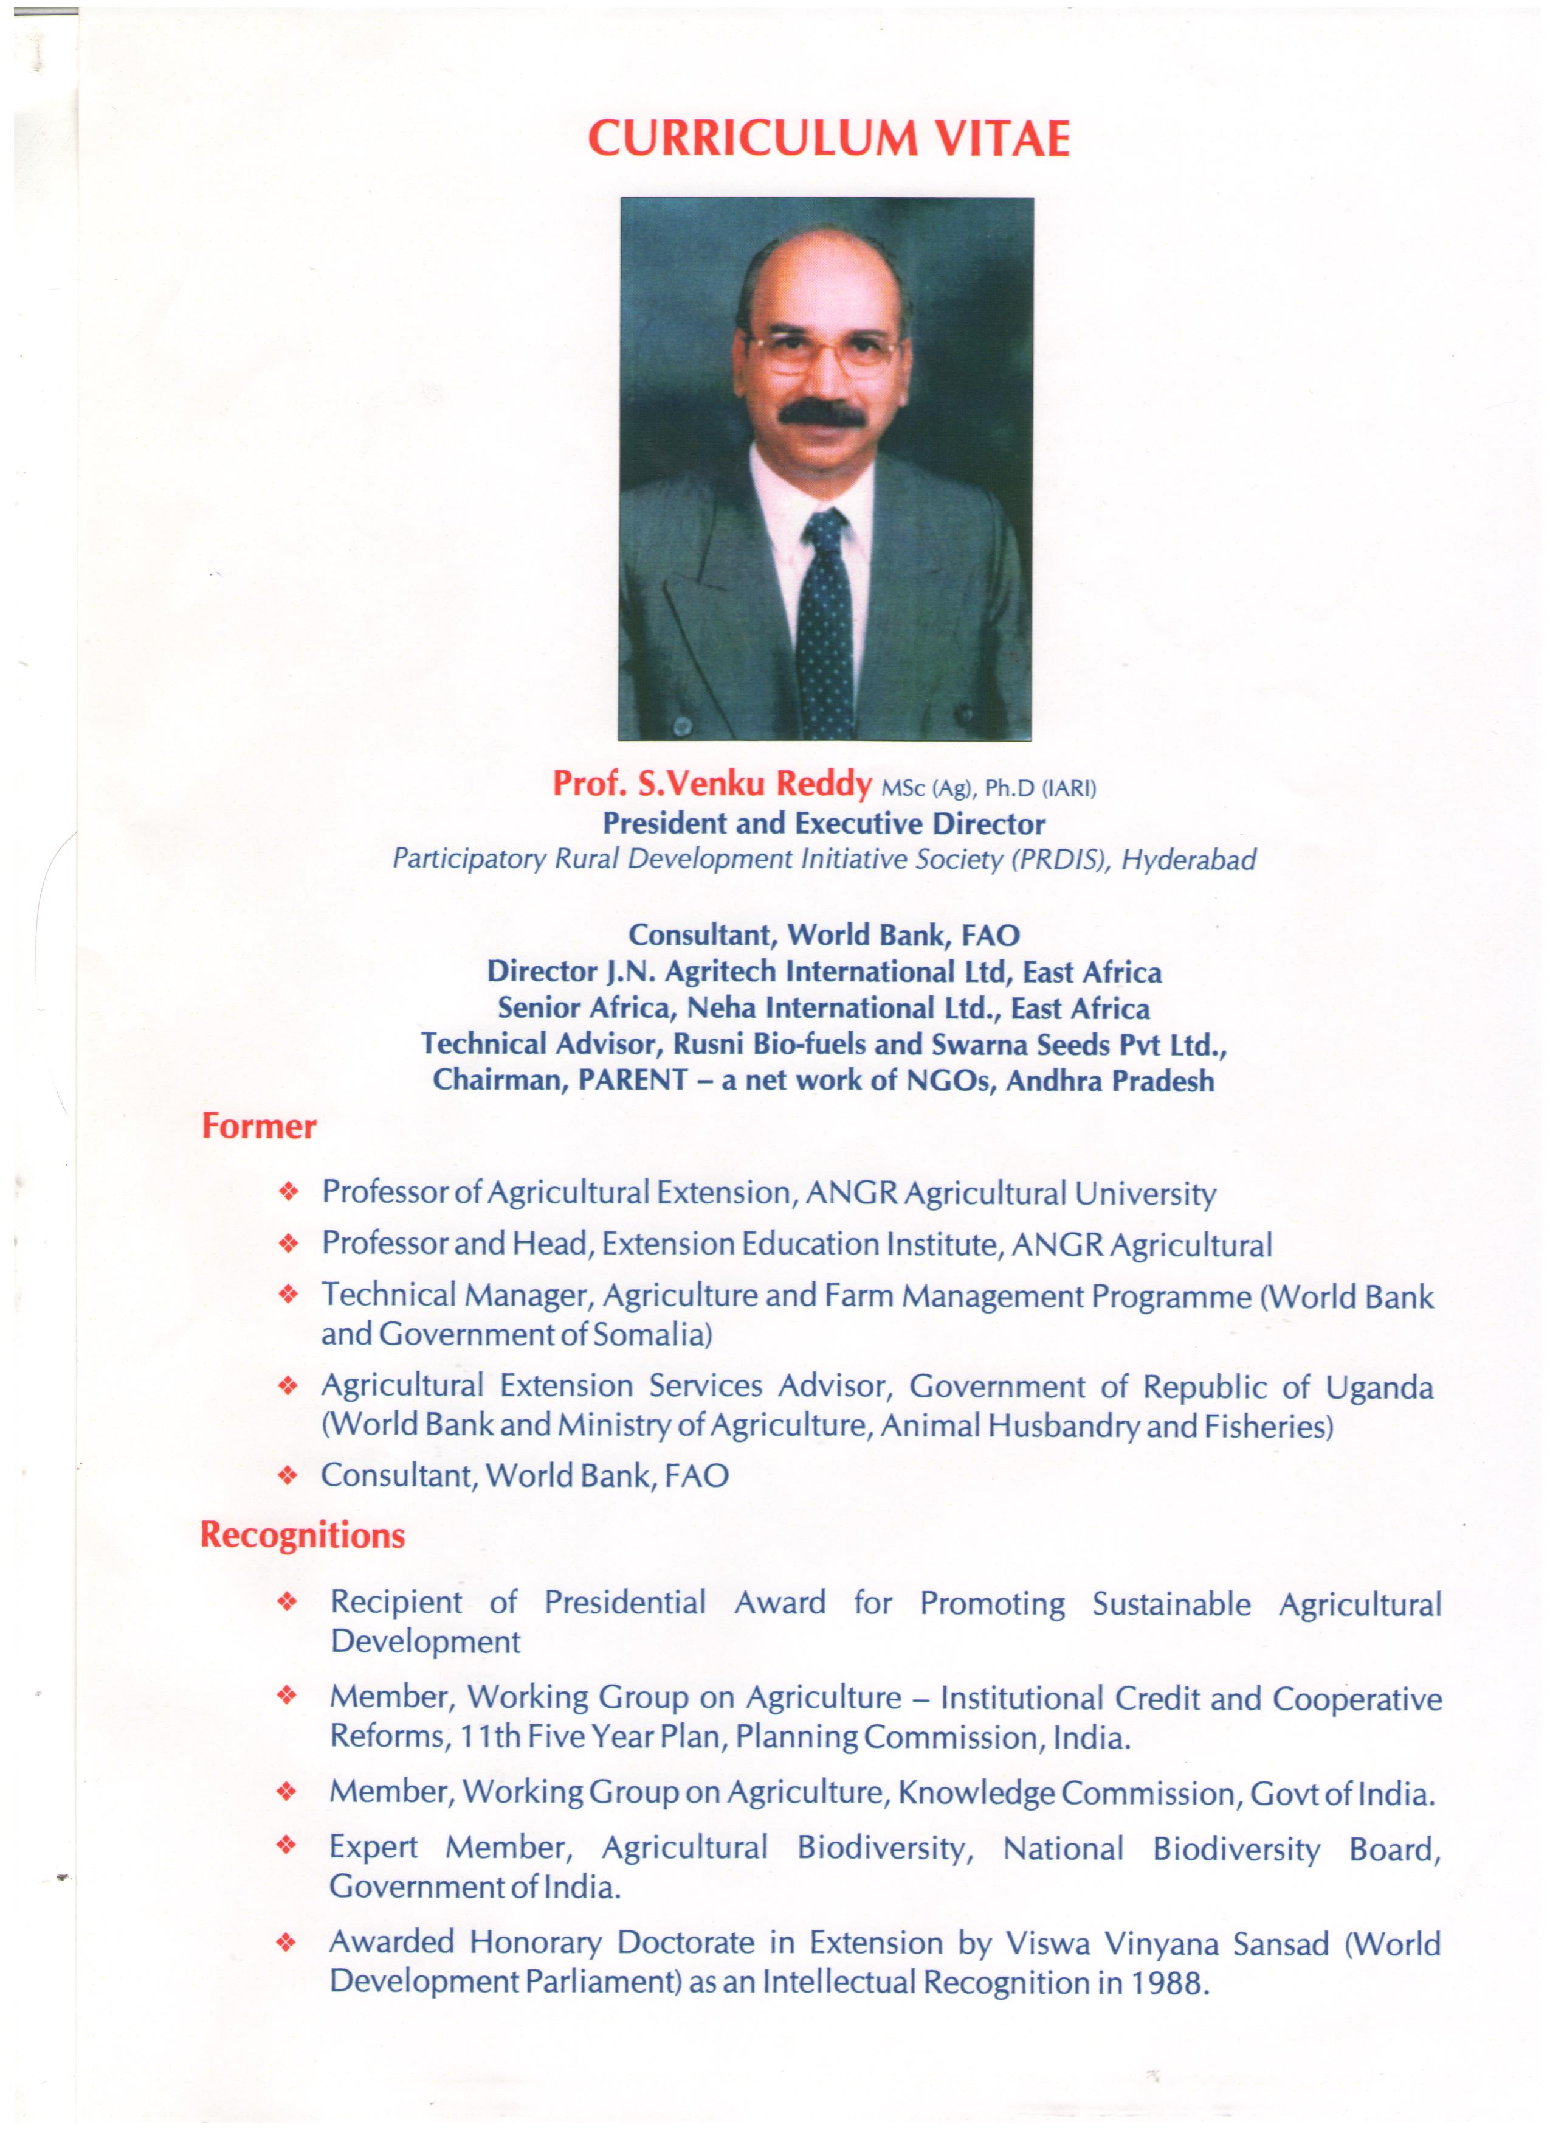

Resume of Prof. S.Venku Reddy
President and Executive Director
Participatory Rural Development Initiatives Society (PRDIS)

& Consultant, World Bank, FAO

1. NAME : Prof. VENKU REDDY SARVAREDDY

2. PRESENT ADDRESS : 8-2-310/A/113 Apt B-2, Pooja Mansion,
Road No 14, Banjara Hills,
Hyderabad – 500 034,A.P. INDIA
Phone: 0091-40-23548100
(O) 040: 24010544 Cell No: 9440051598.
E.mail: sarvareddy@yahoo.com
prdis@hotmail.com
3. EDUCATIONAL BACKGROUND

Ph.D | Major : Agricultural Extension  Minor : Agronomy | Indian Agricultural Research  Institute, New Delhi (1971)- Won ICAR Gold medal for highest OGPA | First Division
M.Sc | Extension Education | Andhra Pradesh Agricultural University, Rajendranagar, Hyderabad, India (1967) | First Division
B.Sc | Agriculture | Andhra Pradesh Agricultural University, Rajendranagar, Hyderabad, India (1965) | Higher Second Division
Awarded honorary doctorate in extension by Viswa Vinyana Sansad (World Development Parliament) as an intellectual recognition in (1988).

4. EMPLOYMENT HIGHLIGHTS

President and Executive Director, Participatory Rural Development Initiatives Society (PRDIS) Basheerbagh, Hyderabad –34 (January 1999 – till date)

Agricultural Extension Services Advisor, Ministry of Agriculture, A.H and Fisheries Government of Republic of Uganda, Post Box 4463, World Bank Resident Mission, Kampala (March 1992 to December 1998)

Consultant, World Bank (February 1991-February 1992)

Technical Manager, Second Agricultural Extension and Training Project, P.O Box 2737, Mogadishu, Somalia, (IDA and ADF funded project) (June 1988 – January 1991)

Professor & Head, Extension Education Institute, Andhra Pradesh Agricultural University, Rajendranagar, Hyderabad (India) (September 1982 – May 1988)

Associate Professor/ Asst Professor, Extension Education Institute / Agricultural Colleges, Andhra Pradesh Agricultural University, Rajendranagar, Hyderabad – (India) (June 1964 – August 1982).

- AREAS OF SPECIALISATION AND INTERESTS:

- Agricultural Extension Management
- Integrated Rural Development
- Agricultural Training and Human Resource Development
- Monitoring, Evaluation & Studies
- Extension Communication
- Participatory Planning & Technology Development
- Agribusiness Management
- Natural Resource Management
- Project Preparation, Management and Evaluation
- Agronomy with special emphasis on Crop Production and Farming
Systems.
- Integrated Pest Management (IPM), Organic Farming and Farmer Field
Schools (FFS)
- Institutional Building
- International Extension

- PROFESSIONAL EXPERIENCE

•Teaching - 22Years •Training - 35Years
•Management- 40Years •Research - 30Years

Additional Professional Experience

- Directed, Supervised and guided the technical programmes of field extension, training, monitoring and evaluation and women and youth development units of National Extension service at Somalia.
- Served as a member of project management unit, National Research Review Committee, Steering Committee of IFAD in planning and implementing several decisions connected with Extension Project at Somalia. Also gained insight into logistics of procurement and financial management.
- Introduced innovative methodologies for transfer of technology to extension workers and farmers under T&V System at India, Somalia and Uganda.
- Introduced and guided in implementation of New Interventions such as Village Level Participatory Approach; Decentralisation; Cost Sharing and outsourcing of extension services to strengthen extension delivery in Uganda.
- Provided input in integration of NGO efforts in unified extension services in Uganda
- Gained experience in conducting feasibility studies, preparation of project completion reports, work plans project proposals and preparation reports.
- Travelled widely abroad on exposure visits in Agriculture to number of countries in Africa, Israel, Peru, Gayana, U.S.A, Europe, Thailand, Philippines and other Asian countries and got insights in to agricultural development and International agricultural extension and research.
- Undertaken and directed six research projects on developmental communication, evaluation of rural development programmes Impact Assessment of Integrated Pest Management in Cotton and agricultural technology in collaboration with National and International organizations.
- Attended and presented papers in about 70 Conferences / Workshops / Seminars of National and International organizations (1972 to till today)
- Directed and organized about 384 training programmes for Agricultural and other Rural Development Functionaries.
- Directed and implemented field level, sustainable agricultural and Rural Development programmes such as Farmer Field Schools (FFS) IPM, Watershed management. Village Level Participatory approach, Productivity enhancement of different crops namely cotton, sugarcane, Paddy, ground nut and maize.
- Directed a study on Impact of IPM, based Farmer Field Schools in India, Sponsored by FAO-EU.
- Planned & Executed Better Cotton Initiative (BCI) and Sustainable Sugarcane Initiative Programmes for benefit of about 20,000 small scale farmerswith the support of Agricultural University, BCFTP, Solidaridad and WHO.
- Served as Director, J.N.Agritec International Ltd., Uganda and Advisor, NEHA International Ltd., Uganda.
- Served as member, Working Group, Agriculture, Planning Commission, New Delhi for XI & XII th Five Year Plan preparation.
- Served as member, working group, Agriculture Extension Knowledge Commission, GoI.
- Member Agri Biodiversity committee and Biodiversity Management Committee of National Bio diversity Board, GoI.

7. REFEREES

- Dr. V.Sadamate , Former Advisor (Agriculture), Planning Commission,
Government of India & currently convergence expert, Nieranchal Project, World Bank, New Delhi.
- Dr. Daniel Gustafson, Dy. Director General, Food and Agriculture Organisation of United Nations (FAO), Rome.
- Dr. A.Padmaraju, Vice Chancellor, ANGR Agricultural University, Rajendranagar, Hyderabad -500 030.
- Dr. Raghuvardhan Reddy, Former Vice Chancellor, ANGRAU Agricultural University, Hyderabad – 500 030.

